Futures Settlement Price Discovery Algorithm

Settlement futures prices are defined in accordance with the internal documents of PJSC Moscow Exchange and JSC NCC.

Parameters used to define Settlement prices are as follows:
Asset type | Time of collection of Market data for the day clearing session  (MDtimeIcl) | Time of collection of Market data for the evening clearing session  (MDtimeEcl) | Frequency of Market data collections  (freq) | Number of market data collections  (count) | Parameter for establishing priority of market data  (spread)
All except Russian shares | 3 minutes | 2 minutes | 5 seconds | 12 | 0.2
Russian shares | 3 minutes | 13 minutes | 5 seconds | 12 | 0.2

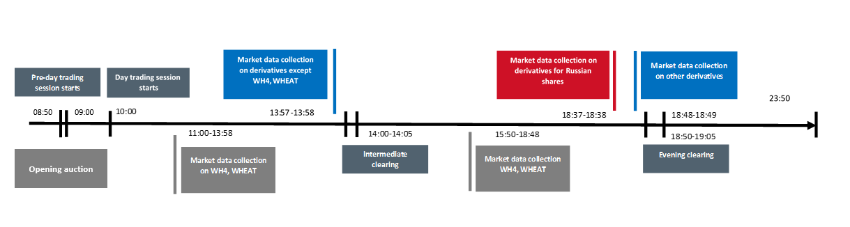
Market data collection on derivatives

For active futures (market data priority = 1):
Starting from the moment MDtime before the clearing session every freq seconds count number of times on all instruments best bids bid, asks ask and last prices last are collected.

Filtered values bid, ask and last are calculated as a median of the downloaded data. Settlement price is equal to the median of the filtered values bid, ask and last.

Sample 1: Median of the downloaded data is used as Settlement price
Market Data
Bid | Last | Ask
118110 | 118130 | 118250
118530 | 118600 | 118760
118560 | 118570 | 118570
118590 | 118590 | 118620
118230 | 118320 | 118400
118220 | 118440 | 118380
118640 | 118560 | 118890
118670 | 118680 | 118700
118700 | 118800 | 118750
118340 | 118920 | 118530
Filtered Data
118545 | 118580 | 118595
Settlement Price
118580

Sample 2: Settlement price is based on the bid price as bids improve last price.

Market Data
Bid | Last | Ask
118110 | 118130 | 118250
118530 | 118130 | 118760
118560 | 118130 | 118570
118590 | 118130 | 118620
118230 | 118130 | 118400
118220 | 118130 | 118380
118640 | 118130 | 118890
118670 | 118130 | 118700
118700 | 118130 | 118750
118340 | 118130 | 118530
Filtered Data
118545 | 118130 | 118595
Settlement Price
118545

For non-active futures (market data priority = 2):

If another futures contract with this underlying asset contains first priority market data, the settlement price of the non-active futures is based on the active futures price and the uploaded interest rate curve.

Market data is considered to be of second priority if any of the filtered values bid, ask or last are missing, or if the bid/ask spread is bigger than spread*MR1 % of the quote, where MR1 is the minimum restrictive level of the initial margin rate Level 1 for the underlying asset.

Example:

If futures Num = 2 is non-active, its Settlement price is discovered in the following way:

SP (2) = SP (spot)* (1 + r * T), where SP (spot) is the spot settlement price, T – time to futures expiration, r – interest rate for the underlying asset for period T.

Spot settlement price is based on the market data if the asset is traded in the EQ or FX market and defined as per the futures algorithm (can be first or second priority). It can also be defined by haircutting the futures SP with first priority for the current date.

