Member's Personal Account
User Guide

Contents
Introduction 4
Description of the menu 5
1. Section "Main" 6
2. Section "Identifiers" 6
3. Section "Reporting" 6
4. Section "Instructions" 7
❖ Generation of documents 7
❖ Sending messages/documents 7
❖ Archive of sent documents 7
❖ Selecting OFZ issues 7
4.1. Sub-section "Generation of documents" 7
4.2. Section "Sending messages/documents" 9
4.3. Subsection "Archive of documents sent" 10
4.4. Section "Selecting OFZ issues" 11
5. Section "Client registration” 12
6. Section "News" 14
❖ "News and notices" 14
❖ "Subscription" 14
7. Section "Client’s Personal Accounts" 14
8. Section "Client Profile" 15
❖ "Request to update the profile" 15
❖ "Company documents" 15
❖ "Accepted Client Questionnaire (legal entity)" 15
❖ "Accepted statements" 15
9. Section "Reporting" 16
❖ "Reporting" 16
❖ "Testing of XBRL reporting" 16
❖ "Statement of regulatory ratios" 16
9.1. Subection "Reporting" 16
9.2. Subsection "Testing of XBRL reporting" 18
9.3. Subsection "Statement of regulatory ratios" 18
10. Section "Client Questionnaire (legal entity)" 18
11. Section "SMA" 19
12. Section "Certification Authority services" 21
❖ "Software statement" 21
❖ "Initial creation of the certificate" 21
❖ "Scheduled certificate replacement" 21
❖ "Changing the certificate details" 21
❖ "Certificate update" 21
❖ "Certificate list". 21
13. Section "Maintenance" 21
14. Section "Financial documents" 22
❖ "Accounts and financial documents" 22
❖ "Debt control" 22
❖ "Duplicate documents request" 22
15. Section "OTC" 22
16. Section "BOARD" 22
17. Section "Active Users" 22
18. Section "Account Manager" 22
19. Section "Calculation of risks for non-traded instruments" 23
❖ "Regular calculation" 23
❖ "One-time calculation" 23
20. Section "Matrix power of attorney" 24
Schedule 1 27
Schedule 2 29

Introduction
This document describes the functioning principles of the Member’s Personal Account software (the "Personal Account").
A Personal Account allows enhancing the customer experience by providing various options in data transmission and actions through the account.
All documents received electronically by the Exchange from a user through the Personal Account shall be considered submitted to the Exchange in accordance with the Rules.
How to get access
The provision of access to the Personal Account is governed by Procedure for Gaining Access to the Member's Personal Account infoware (Schedule 1).
User workstation requirements:
- Internet access;
- Browser: Internet Explorer version 9.0 or higher, Mozilla Firefox or Google Chrome.
Authorisation
To get started, go to the login page https://cabinet.moex.com from the Moscow Exchange website.
For authorisation, enter the email and password received in accordance with the Procedure for Gaining Access to the Member's Personal Account infoware (Schedule 1).

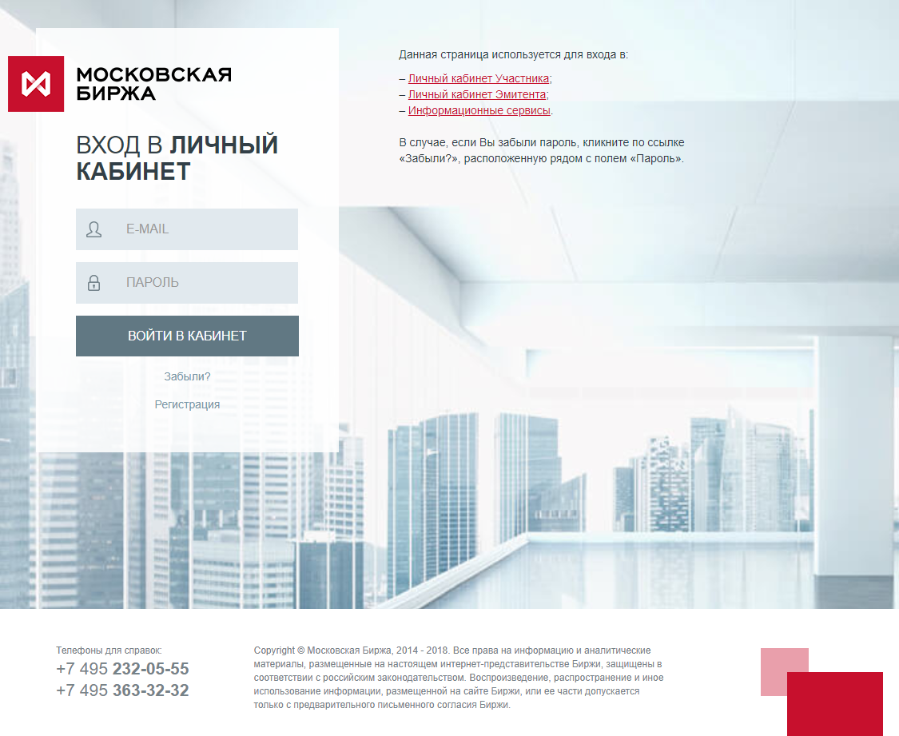
After successful authorisation, the User is in the "Client Accounts" section.

Description of the menu
The main menu is arranged horizontally and consists of sections:
- Main
- Identifiers
- Reporting
- Instructions
- Client registration
- News
- Client accounts
The additional menu opens when you click on and consists of:
- Client's profile
- Reporting
- Client Questionnaire (legal entity)
- SMA
- Certification Authority services
- Technical access
- Financial documents
- ОТС
- BOARD
- Active users
- Account manager
- Calculation of risks for non-traded instruments
- Matrix power of attorney
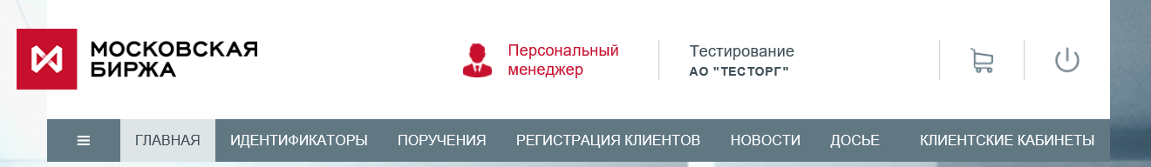
You can go to the "Account Manager" section or ask a question from any section by clicking on the icon (if your organisation does not have an account manager, the icon will not be displayed)
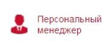

Section "Main"
This section contains basic information about the company, such as:
- full company name
- short company name
- Unicode of the trading member
- Details of market admission
Information on the markets is derived from the documents submitted and trading membership and clearing service agreements concluded by the Member.

Section "Identifiers"
The section contains links to reports with active identifiers, clicking on the links will make an on-line request for up-to-date information from the database.
You can obtain information for each market individually or for all markets in a single Excel file ("Report for all markets").
The downloaded document has a "p7a" extension, i.e. the file is signed and encrypted:
- Signed on behalf of authorised employee E. Gilod.
- Documents are encrypted with regard to all certificates of the company

Section "Reporting"
The "Reporting" section contains links to trade and clearing reports in signed and/or encrypted form. The report can be downloaded within 14 calendar days of the link being posted. In the upper right corner, there is an example of the FTPSReportsDownloader report downloader (the source code of the report downloader can be added to suit your own requirements).
Note: the procedure for obtaining archive reports and reports posted after the issuance of a new secret key remains unchanged.
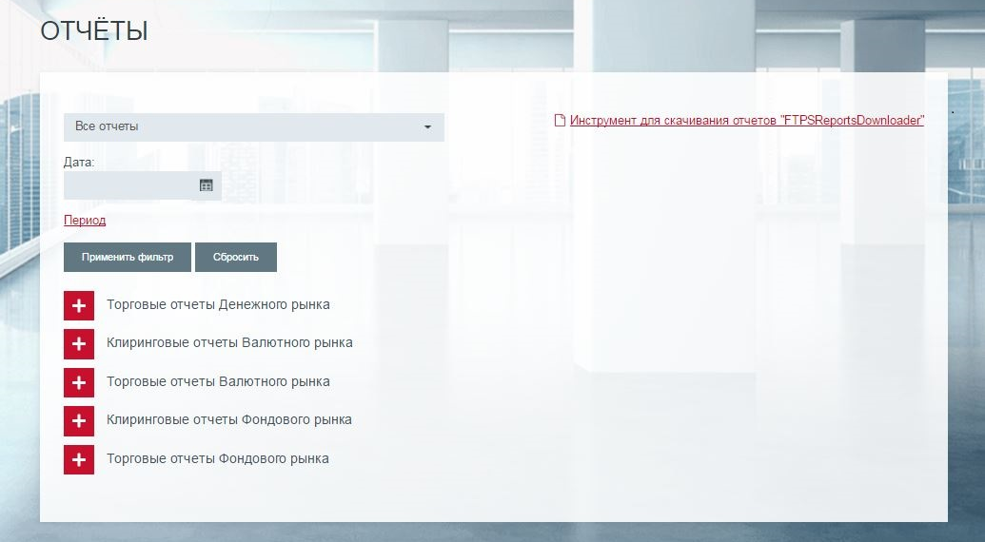
Further information is provided in "Trade and Clearing Reporting".pdf.

Section "Instructions"
The section consists of the following blocks:

Generation of documents

Sending messages/documents

Archive of sent documents

Selecting OFZ issues

Sub-section "Generation of documents"
The functions of this sub-section allow you to generate a document, sign it (ES) and send it via the Personal Account to the Exchange.
Step-by-step guidelines:
- Select values in the "Market" and "Document" fields
- Fill in the form (mandatory fields are marked with a red asterisk *)
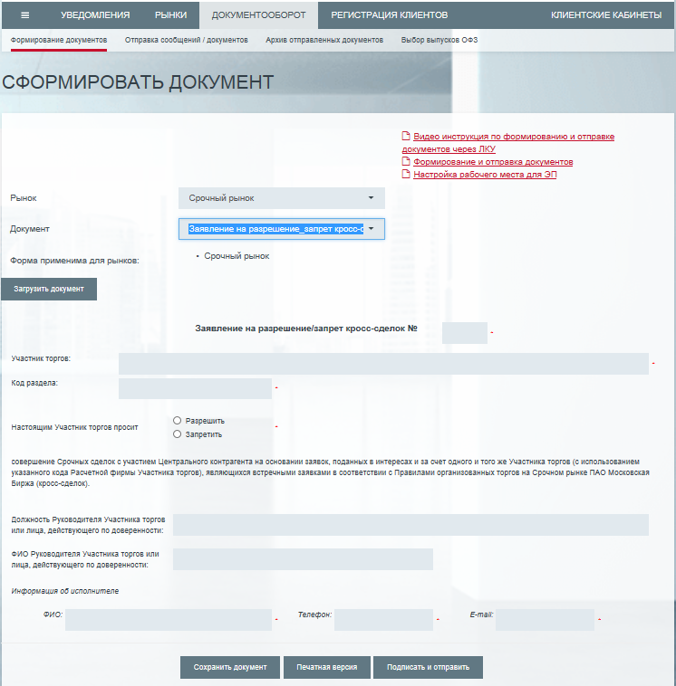
- Then click on:

Button name | Description of generated file
Save the document | Document in xml format (used to save the document template and upload it later)
Print version | Document in html format
Sign and send | The document with the ES is sent to the Exchange through the Personal Account
Note: when sent, the message header is automatically created and corresponds to the title of the document being created
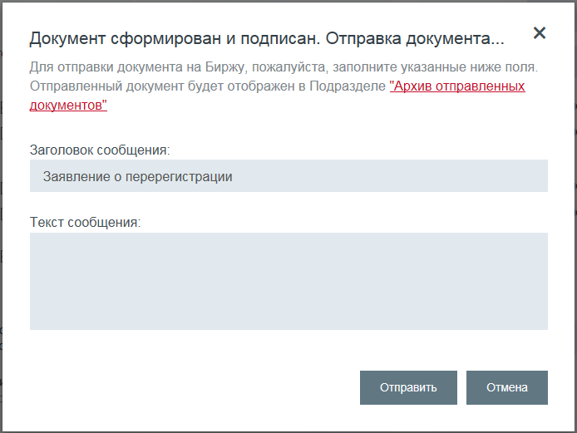
To sign documents with an ES via the Personal Account, the ValidataTerminal software must be installed and the workstation must be configured (see "Step-by-step instructions for configuring the workstation (signing documents with an ES via the Personal Account)" for further details.
The document is signed with the key issued to an employee of the company who is authorised to sign the relevant documents on behalf of the company on the basis of a power of attorney (or other supporting documents).
Encryption is not required when the document is sent via the Personal Account, as the data is transmitted by a secure channel. If necessary, the document can be manually encrypted by the user to Elena Gilod, an authorised member of Moscow Exchange's Customer Support Department.
- Monitor messages/documents sent in the section "Archive of documents sent" of the Personal Account.
Note: A notification will be sent to the user's email address when the status of the document is changed and/or an Exchange comment appears.

Section "Sending messages/documents"
The features of this subsection allow you to sign (ES) a document and send it to the Exchange via the Personal Account or send a pre-signed (ES) document to the Exchange via the Personal Account.
Step-by-step guidelines (mandatory fields are marked with a red asterisk *)
- Select one of the four Moscow Exchange Group companies
- Select the document type (when selecting the document type, the subject is filled in automatically)
- Attach the document to be sent (MS WORD/PDF file)
- Then click on:

Button name | Action
Sign and send the document | The document with the ES is sent to the Exchange through the Personal Account
Send the document | The pre-signed (ES) document is sent to the Exchange via the Personal Account

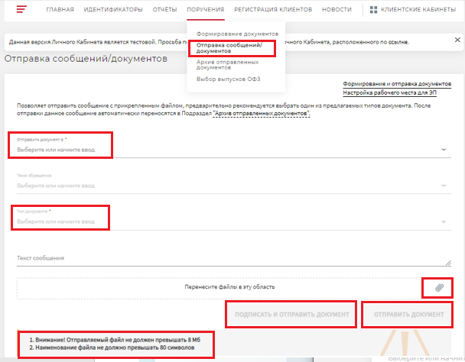
General restrictions:
1.the file must not exceed 8 MB
2. The name of the attached file must not exceed 80 characters
3. Documents signed with an electronic signature shall be verified for compliance with the user account and the electronic signature certificate holder in accordance with the Moscow Exchange Group's existing information security procedures ("Sign and send document" service).
Messages/documents sent via the Personal Account are shown in the "Archive of documents sent" section.

Subsection "Archive of documents sent"
The page contains details of previously sent vis the Personal Account documents (exception: Client registration file)
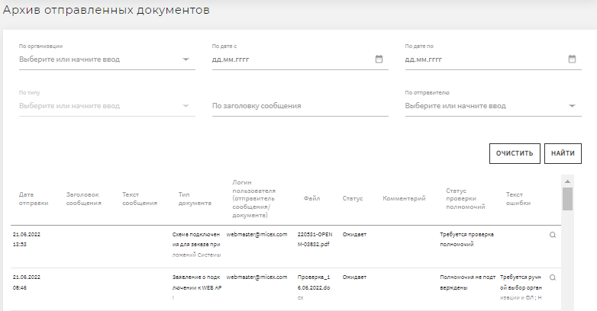

Section "Selecting OFZ issues"
The subsection is intended for trading members who sell OFZ basket futures contracts ("OFZ Seller") and wish to deliver OFZ under the futures traded on the Derivatives Market to the Bond Market. I.e. the trading member should have short positions in the OFZ basket futures contracts at the time of settlement.
In the subsection, the OFZ Seller selects the required OFZ issues for delivery from the basket of issues under the futures contract. Then exports this information to a csv file and sends it via EDI to the NCC Derivatives Market team.
- The selection process is step-by-step and starts with specifying the "Position subaccount number" (appears after clicking on "Add"):
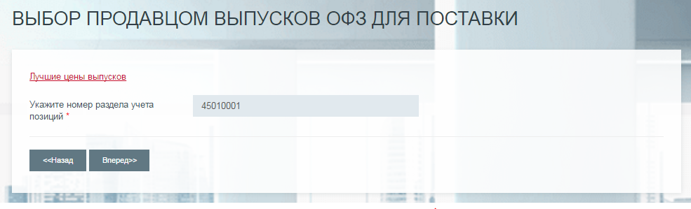
- After specifying the position subaccount number, the user proceeds to the window to add a short position in the futures contract. To enter a position in the futures contract, press "Add", select the futures contract from the drop-down list and enter the number of contracts.
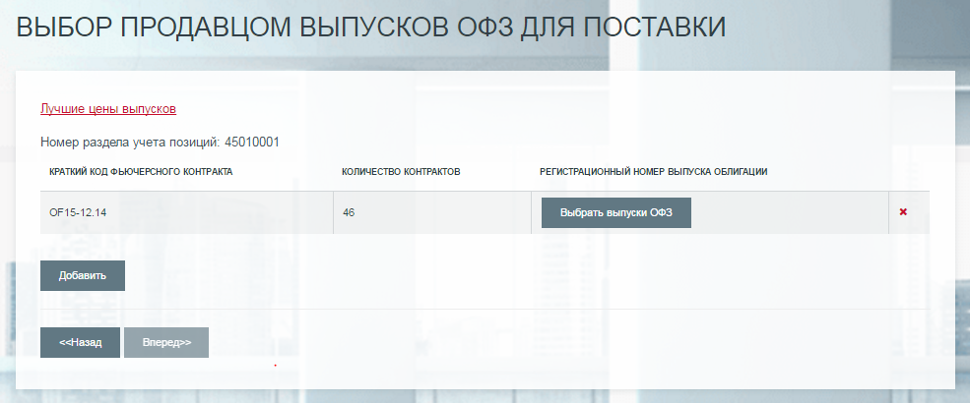
Important notice: you cannot add a repeating futures contract and you cannot enter a zero number of contracts.
- Next, select the OFZ issues to be delivered using "Select OFZ issues"
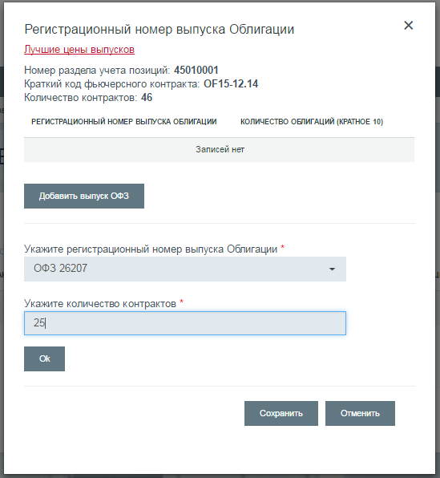
Important notice: you cannot enter a repeating OFZ issue and you cannot enter a zero number of contracts.
Press "Next" to move to the summary table, from which the data is exported to the csv file. To return to the previous editing step, press "Back".

Section "Client registration”
In this section, you can generate a Unified Client Registration xml file ("Unified Client Registration").
For more information on the Unified Client Registration, please follow this link.
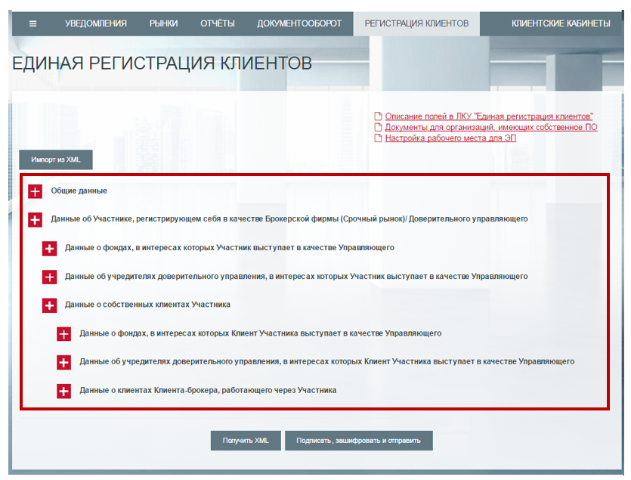
Step-by-step guidelines:
- Fill in the "General data" box (note: You can see the Member's Unicode in the Personal Account - Markets, or check with your personal manager)
- Select and expand the box according to the type of customer you want to register. Click on "Add record"
- Enter the required information in the pop-up window (mandatory fields are marked with a red asterisk *)
- Click on "Save". The basic information is then displayed in the block table. You can enter data for several client (the number is not limited) into one file and select the number of client transactions you want.
- Then click on:
Button name | Description of generated file
Get XML | XML document
Sign | The document with an ES is saved on the user's PC
Sign, encrypt and send | The encrypted document with the ES is sent to the Exchange via the Personal Account.  Features:  - Once sent, the file does not appear in the "Archive of documents sent" section  - XML is sent:  - to the company's EDI address where the sender is: do-not-reply@moex.com  - toeclients@ex.micex.ru on behalf of the Member  - Details of further processing of the file are sent to the EDI mailbox

To sign documents with an ES via the Personal Account, the ValidataTerminal software must be installed and the workstation must be configured (see "Step-by-step instructions for configuring the workstation (signing documents with an ES via the Personal Account)" for further details.
The document is signed with an electronic signature by using the key issued to an employee of the company who is authorised to sign the relevant documents on behalf of the company on the basis of a power of attorney (or other supporting documents).
The client registration file is encrypted in the name of the authorised employee of NCC, as well as any existing certificates of the company.
If a section of the website is interrupted, all the information you have entered will be saved. If you access the Unified Client Registration section again, the following pop-up window will appear:
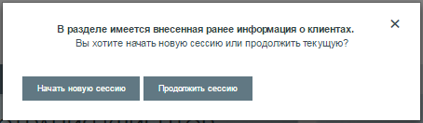
If you click on "Start new session", all previously entered data will be irretrievably deleted. The "Continue the session" button allows you to continue working with previously entered information in the section.
By clicking on "Import from XML" you can upload the previously generated Unified Client registration file (xml) into the account section.
If you have any questions, please contact your account manager at (495) 363-32-32.

Section "News"
The section contains notifications, news and events from the Exchange; when information arrives, an alert is sent to the mailboxes of to the Users’ Personal Accounts, unless the User has specified otherwise in the "Subscription" subsection.
Subsections:

"News and notices"

"Subscription"

Section "Client’s Personal Accounts"
The section allows access to other Moscow Exchange Group accounts.
Visual access image | Description of access
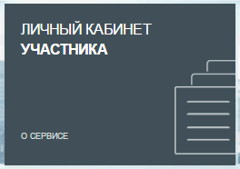 | The active account, i.e. the one (infoware) currently being used by the User, is highlighted in darker colour
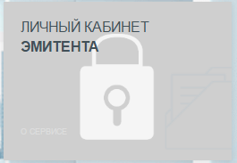 | Unavailable accounts are shown with a "padlock" on the back of the icon
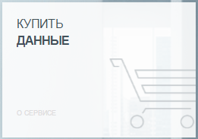 | Account that is accessible has a light grey background
Note: links to other accounts' login/description pages can be found in the "Other Moscow Exchange Group web services" block.
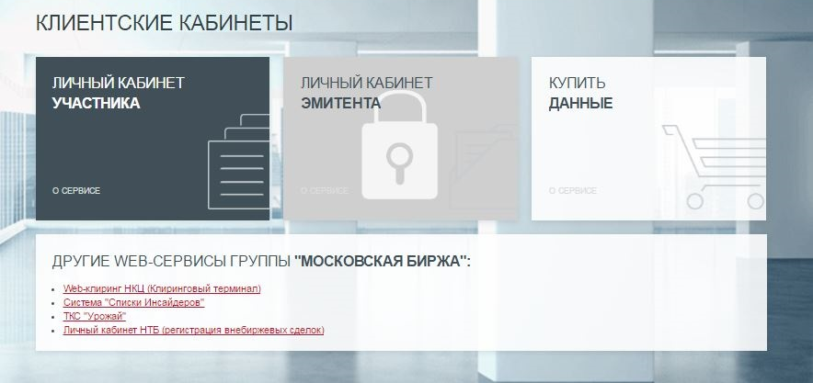

Section "Client Profile"
Subsections:

"Request to update the profile"

"Company documents"

"Accepted Client Questionnaire (legal entity)"

"Accepted statements"
The subsection "Request to update the profile" shows the Requests issued by NCC. When a new Request is issued, an e-mail notification is sent to the user.
Once the entry is assigned the status "Executed" or "Rejected", the Request will be displayed in the subsection for 30 calendar days after the status change.
Other subsections contain information displaying the status of the current profile of the member with the Moscow Exchange Group. The data is updated when new relevant documents are received and processed by the Exchange staff.
The block "Accepted user statements" contains information on the status of the reporting forms (as of the last reporting date) required to be submitted in accordance with the Exchange's internal documents.

Section "Reporting"
Subsections:

"Reporting"

"Testing of XBRL reporting"

"Statement of regulatory ratios"
The subsection "Request to update the profile" shows the Requests issued by NCC. When a new Request is issued, an e-mail notification is sent to the user.

Subsection "Reporting"
The subsection is displayed for all Members, but its contents depend on whether the Member is a credit institution or a non-credit institution.

For non-credit institutions:
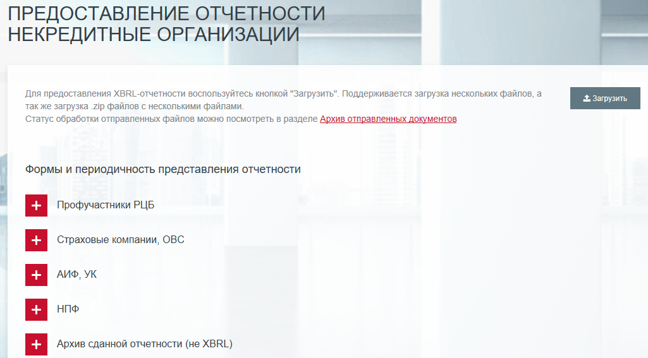
The subsection is for displaying XBRL (eXtensible Business Reporting Language) reporting forms and frequency and uploading them.
Features:
- Submission of XBRL financial reports.
By clicking on "Upload", you will see a window opening to select the file(s) to be uploaded. Only .zip archives with signed files and/or signed files up to 100MB in size will be accepted for upload.
Important note: Files that have not been signed are not handled by our system, so please be careful when selecting files.
For each type of company (professional market participants, non-government pension schemes, insurance companies, etc.), the drop-down box shows a table showing the reporting forms to be submitted and their periodicity.
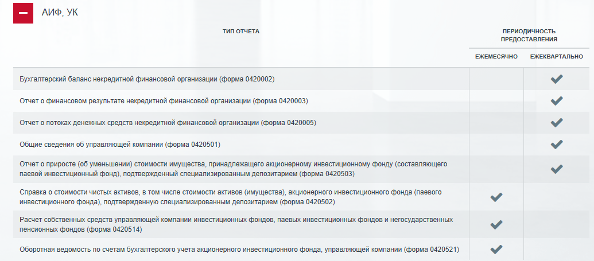
The drop-down box "Archive of Submitted Reports (not XBRL)" displays a table with the status of reports submitted earlier (before 1 February 2018 exclusive) in the old format (not XBRL).
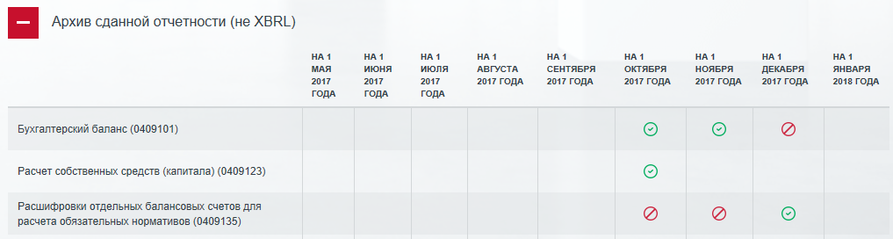
For credit institutions:
The subsection displays a table with the status of reporting on forms for credit institutions.
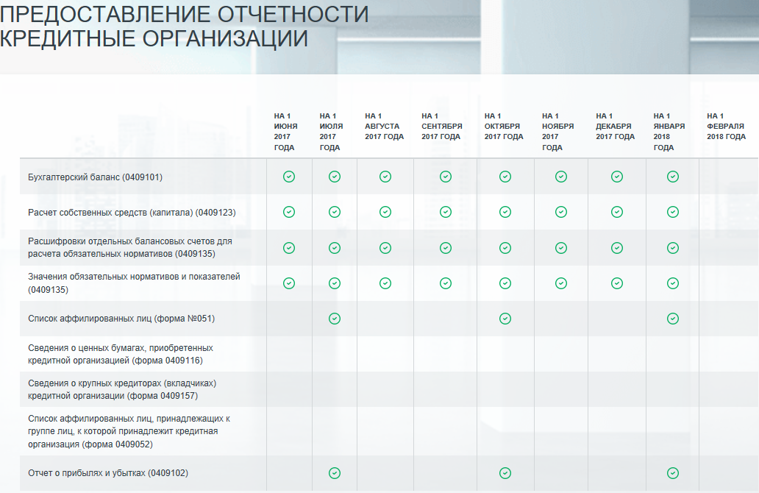

Subsection "Testing of XBRL reporting"
This section is for Members which are not a credit institution and allows you to pre-load an unsigned XBRL report for manual format validation. Once submitted, it is recommended to send an email to the address provided to receive information on the status of the file processing.
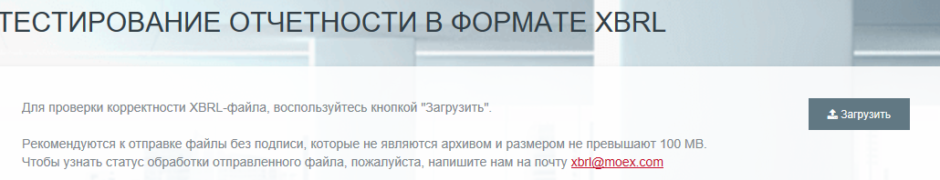
This subsection is not available to Members who are Credit Institutions.

Subsection "Statement of regulatory ratios"
This subsection is only available to credit institutions and is for sending the Member's data on regulatory ratios a monthly basis. The subsection page is as follows:
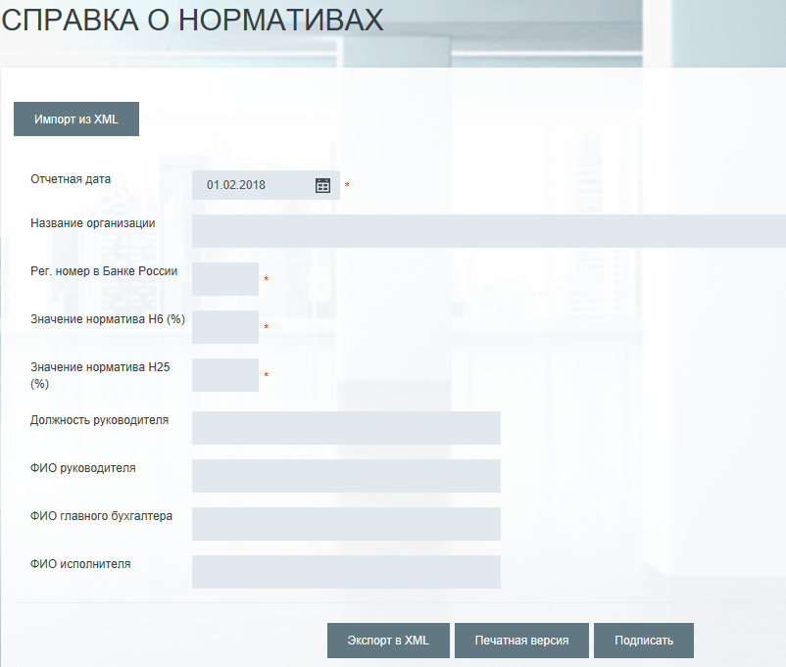
This subsection is not available to Members who are Non-Credit Institutions.

Section "Client Questionnaire (legal entity)"
The information in this subsection is based on the information set forth in the documents provided by the Member in accordance with the internal documents of the Moscow Exchange Group.
The data in this subsection are provided to the extent required from the Member and contained in the Questionnaire provided by the Member.
Step-by-step guidelines:
- Fill in the form (mandatory fields are marked with a red asterisk *)
- Then click on:

Button name | Description of button function
Save data | Completed information will be saved
Export to XML | The XML document is saved on the user's PC
Print version | Print version of the document
Sign | The document with an ES is saved on the user's PC
Sign and send | The document with the ES is sent to the Exchange through the Personal Account
Note: the message header is automatically generated when the message is sent
To sign documents with an ES via the Personal Account, the ValidataTerminal software must be installed and the workstation must be configured (see "Step-by-step instructions for configuring the workstation (signing documents with an ES via the Personal Account)" for further details.
The document is signed with the key issued to an employee of the company who is authorised to sign the relevant documents on behalf of the company on the basis of a power of attorney (or other supporting documents). The document can be signed by an electronic signature of any scope.
Encryption is not required when the document is sent via the Personal Account, as the data is transmitted by a secure channel. If necessary, the document can be manually encrypted by the user to Elena Gilod, an authorised member of Moscow Exchange's Customer Support Department.

- Monitor messages/documents sent in the section "Archive of documents sent" of the Personal Account.
Note: A notification will be sent to the user's email address when the status of the document is changed and/or an Exchange comment appears.

Section "SMA"
In this section, you can generate an .xml file with the restrictions you want to set for the specific SMA ID.
Step-by-step guidelines:
- Select the SMA ID for which you wish to set the restrictions in the "SMA client" field.
- Set restrictions for the SMA identifier in the relevant fields.
- For the restrictions to take effect, the "Activate restrictions" box must be ticked.
- The list of permitted trading modes and securities can only be set through the Personal Account.
- To restrict trading modes for all securities, you need to select default access in the Allowed/ Prohibited Trading Modes List block and then set exceptions to the default rule by selecting the appropriate modes in the list.
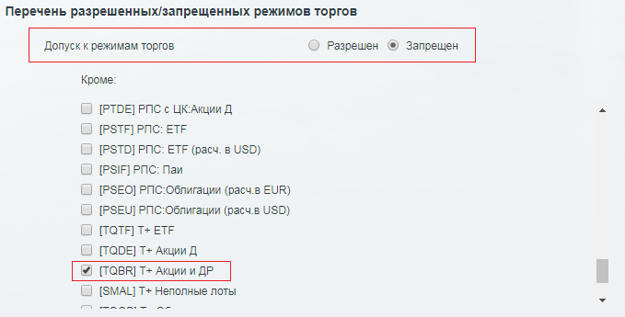
- To set the list of allowed or prohibited securities, you need to select whether access to securities is allowed by default in the Securities Restrictions block, and then set the list of exceptions to the rule.
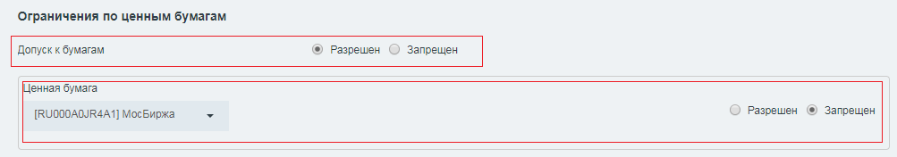
- If it is necessary to restrict the permitted trading modes for a particular security, access to that security must be permitted in the Securities Restrictions block (either by default access to the security is permitted, or by default access to the security is prohibited and that security is on the Exclusion list), and the relevant "Security - Trading Mode" pair to be restricted must be selected in the Allowed/ Prohibited Trading Modes List under the word "Except".
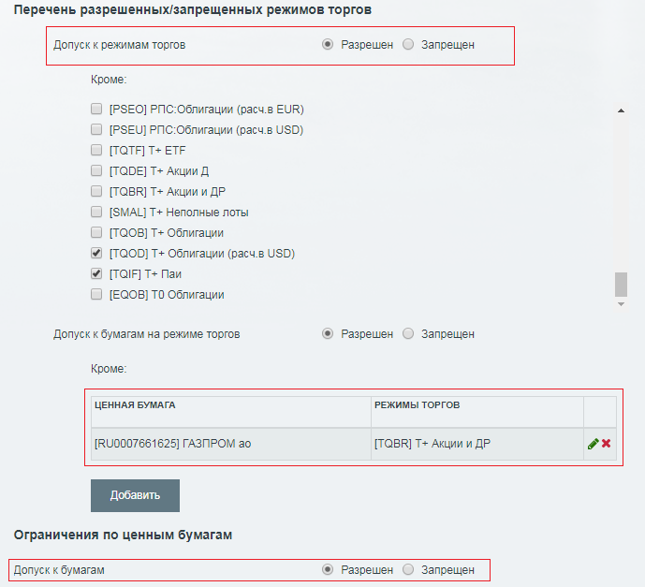
- Then click on:
Button name | Description of generated file
Get XML | XML document
Sign | The document with an ES is saved on the user's PC
Sign, encrypt and send | The encrypted document with the ES is sent to the Exchange via the Personal Account.  Features:  - Once sent, the file does not appear in the "Archive of documents sent" section  - XML is sent:  - to the company's EDI address where the sender is: do-not-reply@moex.com  - tofondinnfb@ex.micex.ru on behalf of the Member  - Details of further processing of the file are sent to the EDI mailbox

To sign documents with an ES via the Personal Account, the ValidataTerminal software must be installed and the workstation must be configured (see "Step-by-step instructions for configuring the workstation (signing documents with an ES via the Personal Account)" for further details.
The document is signed with an electronic signature by using the key issued to an employee of the company who is authorised to sign the relevant documents on behalf of the company on the basis of a power of attorney (or other supporting documents).

Section "Certification Authority services"
The section consists of the following blocks:

"Software statement"

"Initial creation of the certificate"

"Scheduled certificate replacement"

"Changing the certificate details"

"Certificate update"

"Certificate list".
This section allows you to create an ESVKC:
      - in the event of initial production, loss or expiry of the operational key
- in case of scheduled/unscheduled replacement of an active certificate
      - necessity to promptly change the data indicated in the certificate by cancelling the previous certificate with invalid data (details).
The section also enables you to get information about all ESVKCs and update the certificates of your counterparties and EDI CA in the local certificate directories of your PC.
For more information on how to use the section, please follow this link: Instructions for using the updated "Certification Authority Services" section (in Russian)

Section "Maintenance"
Technical access contains a list of contracts with the date on which they were concluded. Each contract can be expanded to view more detailed information.

Section "Financial documents"
Consists of Subsections:

"Accounts and financial documents"

"Debt control"

"Duplicate documents request"
The section contains information on issued invoices, VAT invoices and service statements under Moscow Exchange Group contracts and on current debts.
You can also request duplicate documents specifying your preferred method of despatch (by post or courier).

Section "OTC"
The section allows you to submit reports on over-the-counter transactions. For more information please refer to the OTC Client Web Interface User Guide (in Russian).

Section "BOARD"
MOEX Board membership data consists of organisation status and mode. To view all MOEX Board members in quotation mode, click on the link "All members".
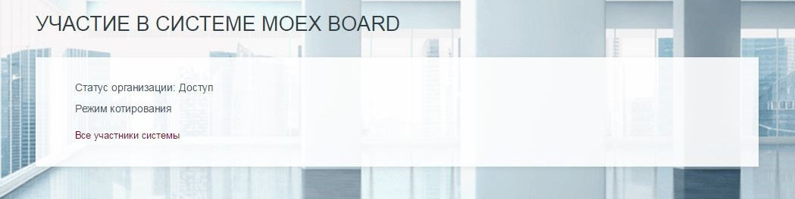

Section "Active Users"
This section contains information on all active users who have access to the account.

Section "Account Manager"
This subsection contains information about the Account Manager; the information is only displayed for Trading Members/Auction bidders.
Features:
- Rate the quality of service.
Under the manager's photo select the number of stars and accompany the rating with a comment.
- Send message
Click on the link "Send message" and send an email to your manager. Once sent, the message will automatically be transferred to the "Archive of documents sent" subsection and the reply to the message can be seen in the column "Comment by Exchange employee".

Section "Calculation of risks for non-traded instruments"
The section consists of the following blocks:

"Regular calculation"

"One-time calculation"
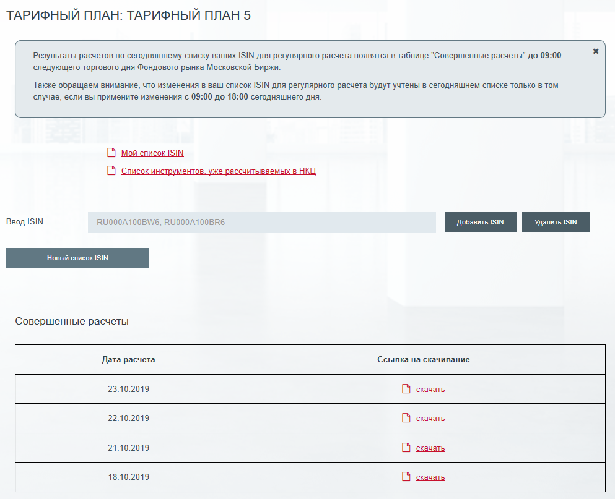
This section allows you to:
- Receive regular (once a trading day) risk calculations by ISIN list, which is set up by the user individually
  - The list of monitored ISIN is available at My ISIN list.
  - The list of all instruments already calculated in NCC is also available under top link
  - To download the ISIN list from a .csv file, use the "New ISIN list" button to open the file selection dialog box
  - To add ISIN to the list, use field "Enter ISIN" and button "Add ISIN".
  - If you click on button "Remove ISIN", the entered ISINs will be removed from the list
  - The calculations are available for downloading in the table by clicking on "download" button
      - Perform one-time calculation of risk by ISIN
  - For one-time calculations, use the "One-time calculation" subsection and enter the required ISIN in the text box
  - All previously calculated risks are displayed in the table under the text field "Enter ISIN".

Step-by-step advice on how to connect to a service that provides indicative risk values for securities:
- It is necessary to download the Application Form available on the page, to connect/disconnect/change the Fee Schedule, fill it out and send it to the Exchange in one of the following ways:
  - Via Personal Account with ES in the tab Instructions -> Sending messages/documents, selecting Message topic - "Identifiers/Technical access", Market - "No market specified", Document type - "Technical service application".
  - Completed application form via EDI.
  - Completed application in hard copy.
- After the application is processed by Moscow Exchange, the functionality of the section will be available to perform calculations

Operating hours:
- One-time calculations are available to Clients from 09:00-24:00 MSK on all trading days of MOEX's Equity & Bond Market.
- Regular calculations are available to Clients from 09:00-19:00 MSK on all trading days of MOEX's Equity & Bond Market.
- Risk rates for regular requests of the current day are published in .csv format in the Personal Account until 09:00 a.m. of the next trading day.
- One-time settlements are made available in the Personal Account within 5 minutes of the request.

Section "Matrix power of attorney"
The functionality of this subsection allows you to issue a power of attorney, sign (ES) and send it via the Personal Account to the Exchange, as well as view a list of matrix powers of attorney for the company.
Step-by-step guidelines for issuing a new Power of Attorney:
- Select "+Add Power of Attorney"
- Fill in the form (mandatory fields are marked with a red asterisk *)
- Select one or more options with the authority
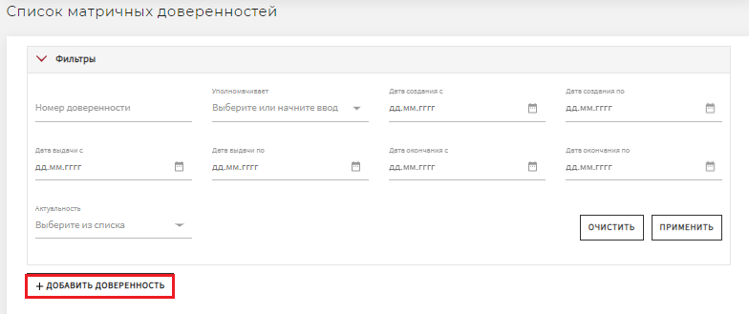

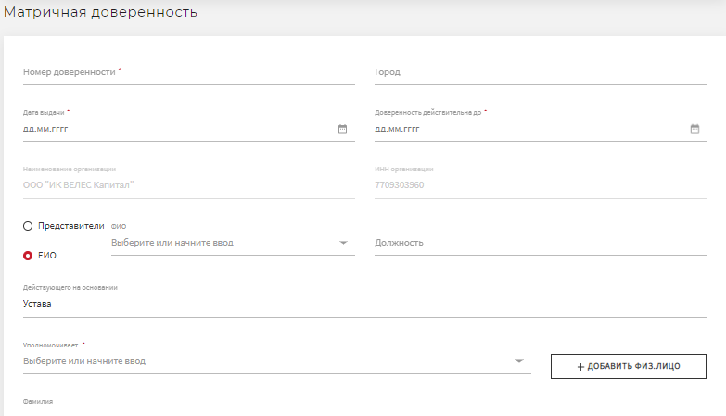
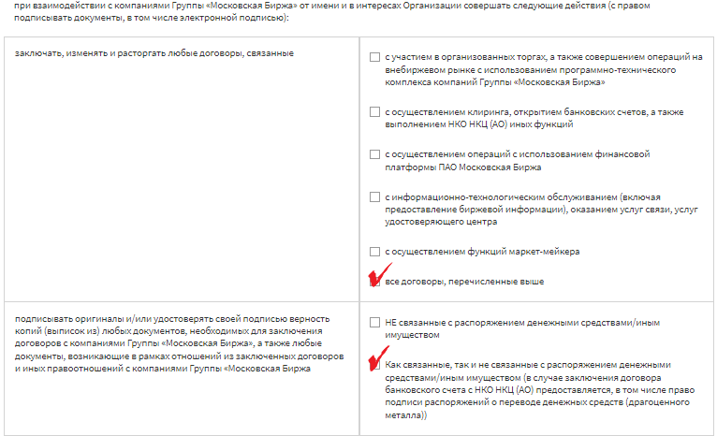
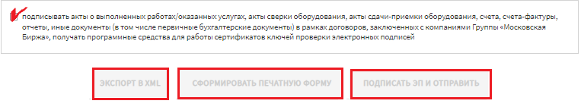

- Then click on:

Button name | Description of button function
Export to XML | The XML document is saved on the user's PC
Generate a printed form | Print version of the document
Sign (ES) and send | The document with the ES is sent to the Exchange through the Personal Account

Schedule 1
User Guide
Member's Personal Account

Procedures to access information support
Member's Personal Account
To gain access to the Personal Account, you need to:
- Complete the registration procedure, making sure to enter the user's first and last name at: https://passport.moex.com/registration (for each employee who will use the Personal Account on behalf of your company). Registration is done with the desired email/password of the user.
- Fill in the application form in Schedule 2 to these Guide, including the details of the users registered under paragraph 1.

Ways to apply:
- By EDI. Before sending, the application shall be signed with the Electronic Signature Key (the "ES") of the CEO or with the ES of the employee under a Power of Attorney to sign electronic documents with the electronic signature if paragraph 2 is noted (in any of the two bullets of the paragraph) in this Power of Attorney. The prepared Application needs to be sent to the Customer Relations team via the Personal Account/"Instructions" section/"Send messages/documents" subsection. It is necessary to select: Send Document to Moscow Exchange / Document Type Application for access to the Personal Account / transfer the signed with the ES and encrypted (if necessary) Application in the Files area and send the document (it is recommended to name the file in MS WORD document format as follows: "Application for access to the Personal Account_company name").
- By post or courier. Companies that do not have a contractual relationship with the Moscow Exchange Group, shall send the Application in hard copy.
The document must be signed and stamped by an authorised person and sent to the address: 13 Bolshoy Kislovsky pereulok Moscow If the Application is signed by a person acting under a power of attorney, a copy of the power of attorney certified by the signature of the authorised person and the company seal must be submitted.
An application shall not be accepted for processing if:
- the form and format do not comply with the requirements;
- failure to verify the electronic signature of the company (when submitting the Application via EDI);
- inconsistency of the signatory's authority with the power of attorney;
- it includes incorrect data, corrections and errors, including spelling and syntax errors.
To comply with the Federal Law No. 152-FZ of 27 July 2006 "On Personal Data", provide a handwritten Consent to Personal Data Processing by the person who signed the Application for access to the Personal Account by the power of attorney and the contact person named in the Application.
Time frame for granting access
No later than 3 (three) working days from the receipt of the documents specified in paragraphs 2 and 3, the users of your company will be granted access to the Personal Account (you will be informed by notification to your postal address). You will be able to log in to the Personal Account section by entering the details indicated in the Application.

Contact details

Companies that are Trading Members
Issues related to  connection to the Personal Account | Issues arising  in the process of operating in the Personal Account
Account manager, tel. +7 (495) 363-32-32

Companies that are not Trading Members
User objective | Issues related to  connection to the Personal Account | Issues arising  in the process of operating in the Personal Account
Access to Member’s Personal Account | Tel: +7 (495) 363 32 32, ext. 35-55,  E-mail: contact@moex.com. | Tel: +7 (495) 733-95-07  E-mail: help@moex.com
Obtaining  information  on financial documents | Tel: +7 (495) 363 32 32, ext. 33-77;  E-mail: help@moex.com | Tel: +7 (495) 363 32 32, ext. 12-20;  E-mail: billing@moex.com
Services under Section "Certification Authority services" |  | Tel: +7 (495) 363 32 32, ext. 11-10;  E-mail: pki@moex.com

Schedule 2
User Guide
Member's Personal Account

Attn Moscow Exchange Group

Application
for access to the information support
Member's Personal Account

We, ___________________________________________________________________
(full name of the legal entity in accordance with the Charter)
TIN_________________, OGRN _______________________________, hereby request access to the information support Member's Personal Account.

Data of registered users on the Moscow Exchange corporate website for connection:

No. | Email | Name, surname  (full) | Action with the user account for access to the Personal Account (insert "+" in the appropriate column)
 |  |  | Add user | Delete user

Contact person for quick contact:

Last name, first name, middle name | Telephone
( )
City code

